**Table of Contents**

**Scope** 2

**SR-IOV Introduction** 2

**Setup and configuring of SR-IOV for LISAv2** 2

**Sample SR-IOV setup details** 4

**Creating and configuring SR-IOV on a virtual switch** 4

**Creating and configuring the virtual machine** 6

**Enabling SR-IOV on the existing Virtual Machine** 7

**LISAv2 SR-IOV test cases** 8

**How to execute Hyper-V SR-IOV test cases** 8

**References** 9

**Scope**

The scope of this document is to detail the configuration of a Hyper-V Server that will be used by LISAv2 to validate the SR-IOV functionality.

**SR-IOV Introduction**

The single root I/O virtualization (SR-IOV) interface is an extension to the PCI Express (PCIe) specification. SR-IOV allows a device, such as a network adapter, to separate access to its resources among various PCIe hardware functions. These functions consist of the following types:

* A PCIe Physical Function (PF)
* One or more PCIe Virtual Functions (VFs)

Each PF and VF is assigned a unique PCI Express Requester ID (RID) that allows an I/O memory management unit (IOMMU) to differentiate between different traffic streams and apply memory and interrupt translations between the PF and VFs. This allows traffic streams to be delivered directly to the appropriate Hyper-V parent or child partition. As a result, nonprivileged data traffic flows from the PF to VF without affecting other VFs.

SR-IOV enables network traffic to bypass the software switch layer of the Hyper-V virtualization stack. Because the VF is assigned to a child partition, the network traffic flows directly between the VF and child partition. As a result, the I/O overhead in the software emulation layer is diminished and achieves network performance that is nearly the same performance as in nonvirtualized environments.

**Setup and configuring of SR-IOV for LISAv2**

**LISAv2** supports both **Mellanox ConnectX-3 Pro** cards and **Intel X520** adapters. These NICs must be capable of communicating to each other. All the SR-IOV tests (functional and performance) are executed on two different Hyper-V hosts and the LISAv2 framework expects that the physical NICs are connected to the same switch.

* For using Mellanox or Intel cards, the latest Windows drivers and firmware must be installed for that specific card. Check Mellanox or Intel websites for the latest drivers & firmware.
* Create an extra vSwitch on each host using SR-IOV capable NIC. The default naming scheme is:

For Functional testing:

* **“SRIOV_MLNX”** should be used for vSwitch name of Mellanox NICs
* **"SRIOV_INTEL”** should be used for vSwitch name for Intel NICs

For Performance testing, **"SRIOV"** should be used for vSwitch name.

* Before configuring the SR-IOV switch, check whether SR-IOV is supported in server with the below command.

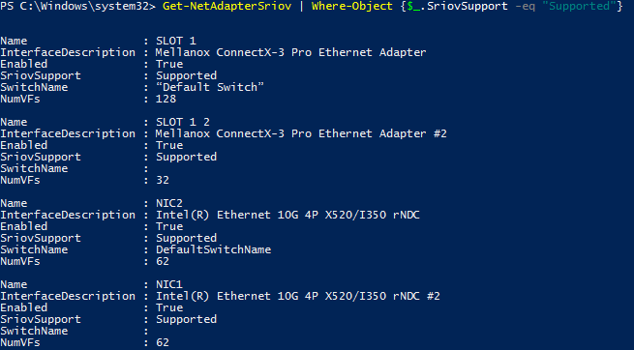

* Once the vSwitches are created, then check if the VFs (Virtual Functions) are available on each host. To Check the number of VF’s available, use the below command.

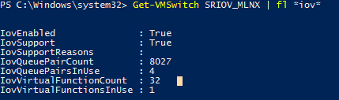

**Sample SR-IOV setup details**

Below diagram shows an environment where three Virtual Machines route their traffic through the VFs directly to the Physical NIC, bypassing the Hypervisor. SR-IOV is configured on the network adapter from Virtual Connect.

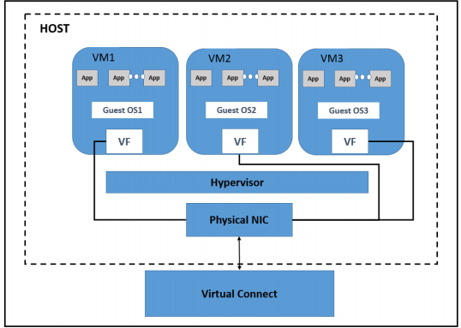

Figure1: SR-IOV setup

**Creating and configuring SR-IOV on a virtual switch**

Steps to create a virtual switch and configure SR-IOV to virtual switch:

1. Create a virtual switch:
   1. Launch Hyper-V Manager.
   2. On the right side of the Hyper-V Manager screen, under the Actions pane, select “Virtual Switch Manager”.
   3. Under Create virtual switch pane, select External, and then click “Create Virtual Switch”.

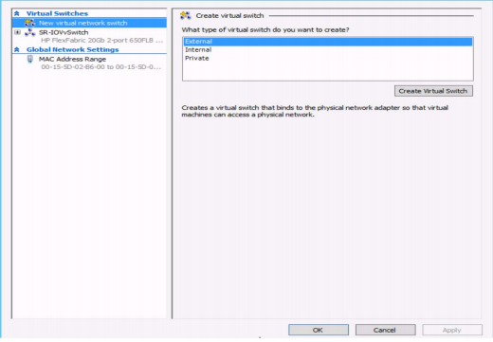

1. Configure the virtual switch properties:
   1. Use the below names for the virtual switch.
      1. Using Mellanox card: **SRIOV_MLNX**
      2. Using Intel card: **SRIOV_INTEL**
   2. Under Connection type, select the correct adapter, and then check the Enable SR-IOV checkbox.

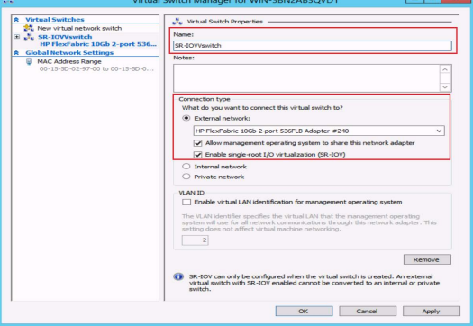

* 1. Click Apply, and then OK.

**Creating and configuring the virtual machine**

Steps to create a virtual machine and connect the network adapter to the virtual switch:

1. Launch Hyper-V Manager.
2. On the right side of the Hyper-V Manager screen, select “New Virtual Machine”. The New Virtual Machine Wizard is displayed.
   1. Click “Next” for “Before You Begin” screen.
   2. Specify name of VM (E.g.: "CENTOS76x64")
   3. Select the type of generation (1 or 2 based on the user requirement)
   4. Specify Startup memory:
      1. 1024 MB for VM without Mellanox
      2. 2048 MB for VM with Mellanox.
   5. Select Network Adapter (SRIOV_MLNX / SRIOV_INTEL)

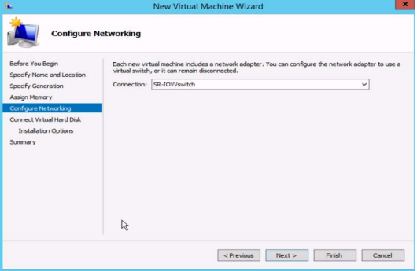

* 1. In the current “connect virtual hard disk” screen, select the appropriate option.
  2. Click next to check the summary and click on finish to create a VM.
  3. Once the VM is created, all integration services need to be selected, click on settings, under Management section, select all integration services.

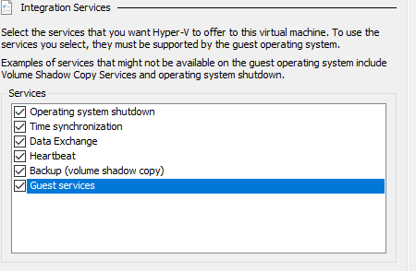

**Enabling SR-IOV on the existing Virtual Machine**

Steps to enable SR-IOV on a virtual machine:

1. Open the VM Settings on newly created VM, expand the “Network adapter” and then select Hardware Acceleration
2. Select the Enable SR-IOV checkbox.

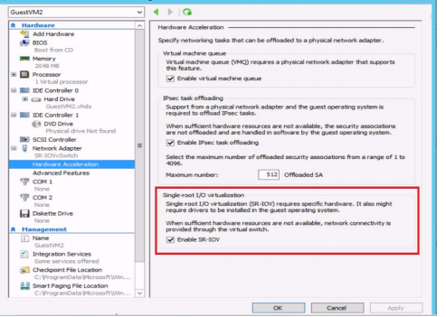

1. Click Apply, and then OK.
2. Once the SRIOV setup is done, login in to VM and execute the command “lspci” to check whether Mellanox/ Intel adapters are present.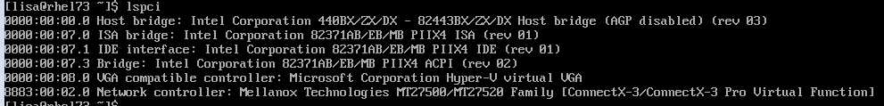

**LISAv2 SR-IOV test cases**

Below is the list of Hyper-V tests related to SR-IOV

|  |  |  |
| --- | --- | --- |
| SRIOV-VERIFY-LSPCI | SRIOV-VERIFY-SINGLE-VF-CONNECTION | SRIOV-VERIFY-SINGLE-VF-CONNECTION-ONE-VCPU |
| SRIOV-VERIFY-SINGLE-VF-CONNECTION-MAX-VCPU | SRIOV-VERIFY-MAX-VF-CONNECTION | SRIOV-VERIFY-MAX-VF-CONNECTION-MAX-VCPU |
| SRIOV-INTERRUPTS-CHANGE | SRIOV-DISABLEVF-ON-GUEST | SRIOV-RELOAD-MODULE |
| SRIOV-DISABLEVF-PING | SRIOV-DISABLEVF-IPERF | SRIOV-DETACH-NIC |
| SRIOV-DISABLEVF-ONHOST | SRIOV-DISABLE-NIC | SRIOV-DISABLE-VMQ |
| SRIOV-CHANGE-RSS | SRIOV-MEASURE-VF-FAILBACK | SRIOV-MULTICAST |
| SRIOV-BROADCAST | SRIOV-REBOOT-VM | SRIOV-STRESS-SAVE |
| SRIOV-STRESS-PAUSE | SRIOV-IPERF-STRESS | SRIOV-DISABLE-ENABLE-PCI |

**How to execute Hyper-V SR-IOV test cases**

Refer the below link for detailed description on how to execute SR-IOV LISAv2 test cases on Hyper-V

<https://github.com/LIS/LISAv2/blob/master/README.md#launch-test-suite>

**References**

<https://docs.microsoft.com/en-us/windows-hardware/drivers/network/overview-of-single-root-i-o-virtualization--sr-iov->

<https://support.hpe.com/hpsc/doc/public/display?docId=emr_na-c04705405>